Assignment 3

1

Code:

libname college 'C:\Users\Samil\Desktop\Sem 1\Stats for programming\SAS 9.4';

**data** college.airport;

infile "C:\Users\Samil\Desktop\Sem 1\Stats for programming\SAS 9.4\airport.csv" firstobs=**2** dsd;

input @**1** CITY : $26. STATE $ ABREV $ PASS95 PASS85;

**run**;

**proc** **print** data=college.airport;

Title "Airport";

**run**;

Title;

Log File:

20 data college.airport;

21 infile "C:\Users\Samil\Desktop\Sem 1\Stats for programming\SAS 9.4\airport.csv" firstobs=2 dsd;

22 input @1 CITY : $26. STATE $ ABREV $ PASS95 PASS85;

23 run;

NOTE: The infile "C:\Users\Samil\Desktop\Sem 1\Stats for programming\SAS 9.4\airport.csv" is:

Filename=C:\Users\Samil\Desktop\Sem 1\Stats for programming\SAS 9.4\airport.csv,

RECFM=V,LRECL=32767,File Size (bytes)=753,

Last Modified=13 September 2017 18:11:23,

Create Time=13 September 2017 18:12:00

NOTE: 20 records were read from the infile "C:\Users\Samil\Desktop\Sem 1\Stats for programming\SAS

9.4\airport.csv".

The minimum record length was 30.

The maximum record length was 52.

NOTE: The data set COLLEGE.AIRPORT has 20 observations and 5 variables.

NOTE: DATA statement used (Total process time):

real time 0.06 seconds

cpu time 0.07 seconds

24

25 proc print data=college.airport;

26 Title "Airport";

27 run;

NOTE: There were 20 observations read from the data set COLLEGE.AIRPORT.

NOTE: PROCEDURE PRINT used (Total process time):

real time 0.13 seconds

cpu time 0.04 seconds

28 Title;

Output:

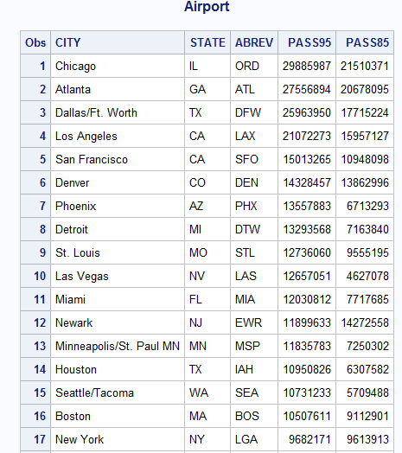

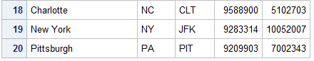

2

Code:

**data** college.ryan;

infile 'C:\Users\Samil\Desktop\Sem 1\Stats for programming\SAS 9.4\ryan.txt' firstobs=**2** missover expandtabs;

input @**1** title $25. roger nytimes usat ;

**proc** **print** data=college.ryan;

Title "Ryan";

**run**;

Title;

Log File:

36 data college.ryan;

37 infile 'C:\Users\Samil\Desktop\Sem 1\Stats for programming\SAS 9.4\ryan.txt' firstobs=2 missover

37 ! expandtabs;

38 input @1 title $25. roger nytimes usat ;

NOTE: The infile 'C:\Users\Samil\Desktop\Sem 1\Stats for programming\SAS 9.4\ryan.txt' is:

Filename=C:\Users\Samil\Desktop\Sem 1\Stats for programming\SAS 9.4\ryan.txt,

RECFM=V,LRECL=32767,File Size (bytes)=541,

Last Modified=05 September 2017 10:16:46,

Create Time=05 September 2017 10:16:46

NOTE: 21 records were read from the infile 'C:\Users\Samil\Desktop\Sem 1\Stats for programming\SAS

9.4\ryan.txt'.

The minimum record length was 13.

The maximum record length was 32.

NOTE: The data set COLLEGE.RYAN has 21 observations and 4 variables.

NOTE: DATA statement used (Total process time):

real time 0.06 seconds

cpu time 0.06 seconds

39 proc print data=college.ryan;

40 Title "Ryan";

41 run;

NOTE: There were 21 observations read from the data set COLLEGE.RYAN.

NOTE: PROCEDURE PRINT used (Total process time):

real time 0.10 seconds

cpu time 0.03 seconds

42 Title;

Output:

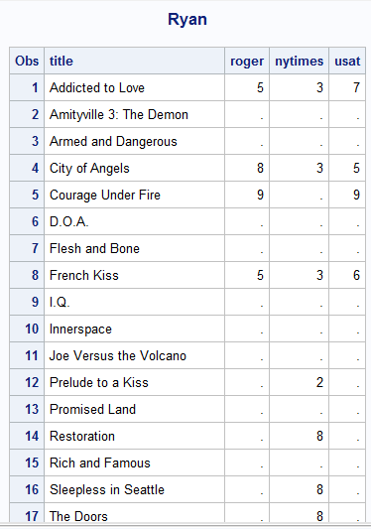 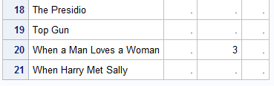

3

Code:

libname college 'C:\Users\Samil\Desktop\Sem 1\Stats for programming\SAS 9.4';

**data** college.hockey;

infile "C:\Users\Samil\Desktop\Sem 1\Stats for programming\SAS 9.4\hockey.csv" firstobs=**2** dsd;

input Date :mmddyy10. Team : $18. City : $17. State : $13. OSU OPP;

**run**;

**proc** **print** data=college.hockey;

Title "Hockey";

**run**;

Title;

Log File:

43 data college.hockey;

44 infile "C:\Users\Samil\Desktop\Sem 1\Stats for programming\SAS 9.4\hockey.csv" firstobs=2 dsd;

45 input Date :mmddyy10. Team : $18. City : $17. State : $13. OSU OPP;

46 run;

NOTE: The infile "C:\Users\Samil\Desktop\Sem 1\Stats for programming\SAS 9.4\hockey.csv" is:

Filename=C:\Users\Samil\Desktop\Sem 1\Stats for programming\SAS 9.4\hockey.csv,

RECFM=V,LRECL=32767,File Size (bytes)=1701,

Last Modified=12 September 2017 22:38:14,

Create Time=13 September 2017 18:40:35

NOTE: 36 records were read from the infile "C:\Users\Samil\Desktop\Sem 1\Stats for programming\SAS

9.4\hockey.csv".

The minimum record length was 35.

The maximum record length was 56.

NOTE: The data set COLLEGE.HOCKEY has 36 observations and 6 variables.

NOTE: DATA statement used (Total process time):

real time 0.31 seconds

cpu time 0.04 seconds

47

48 proc print data=college.hockey;

49 Title "Hockey";

50 run;

NOTE: There were 36 observations read from the data set COLLEGE.HOCKEY.

NOTE: PROCEDURE PRINT used (Total process time):

real time 0.33 seconds

cpu time 0.04 seconds

51 Title;

Output:

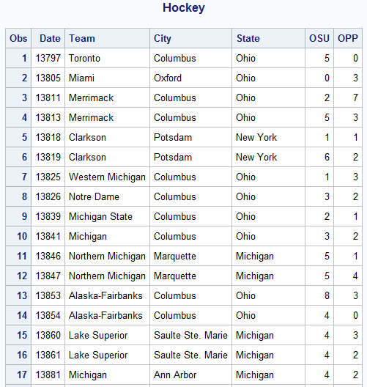

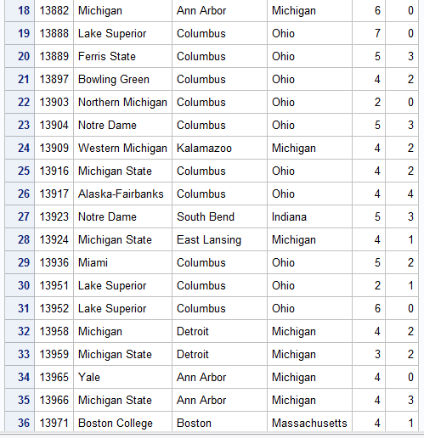

4

Code:

**data** college.limes;

infile "C:\Users\Samil\Desktop\Sem 1\Stats for programming\SAS 9.4\limes.txt" firstobs=**2** dlm=',';

input Date :mmddyy10. Fruit_Dia Fruit_length Fruit_Wt Fruit_vol Juice_Vol Juice_Wt Peel_Wt;

**run**;

**proc** **print** data=college.limes;

Title 'Limes';

**run**;

Title;

Log File:

61 data college.limes;

62 infile "C:\Users\Samil\Desktop\Sem 1\Stats for programming\SAS 9.4\limes.txt" firstobs=2 dlm=','

62 ! ;

63 input Date :mmddyy10. Fruit_Dia Fruit_length Fruit_Wt Fruit_vol Juice_Vol Juice_Wt Peel_Wt;

64 run;

NOTE: The infile "C:\Users\Samil\Desktop\Sem 1\Stats for programming\SAS 9.4\limes.txt" is:

Filename=C:\Users\Samil\Desktop\Sem 1\Stats for programming\SAS 9.4\limes.txt,

RECFM=V,LRECL=32767,File Size (bytes)=4031,

Last Modified=14 September 2017 10:09:35,

Create Time=14 September 2017 10:09:33

NOTE: 100 records were read from the infile "C:\Users\Samil\Desktop\Sem 1\Stats for programming\SAS

9.4\limes.txt".

The minimum record length was 29.

The maximum record length was 42.

NOTE: The data set COLLEGE.LIMES has 100 observations and 8 variables.

NOTE: DATA statement used (Total process time):

real time 0.04 seconds

cpu time 0.01 seconds

65

66 proc print data=college.limes;

67 Title 'Limes';

68 run;

NOTE: There were 100 observations read from the data set COLLEGE.LIMES.

NOTE: PROCEDURE PRINT used (Total process time):

real time 0.17 seconds

cpu time 0.07 seconds

69 Title;

Output:

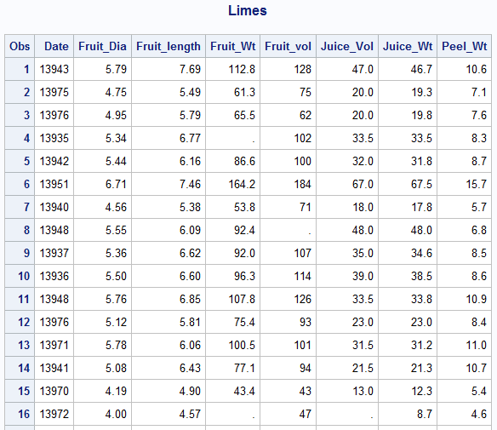

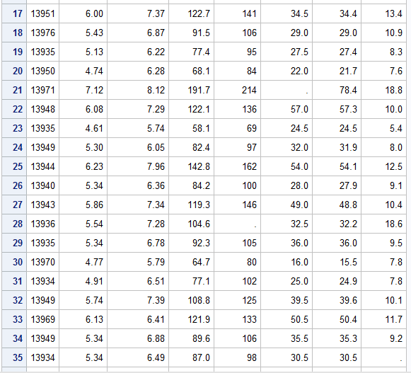

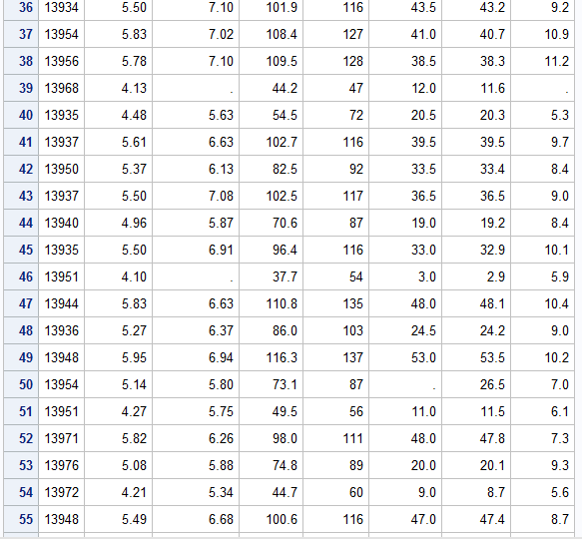

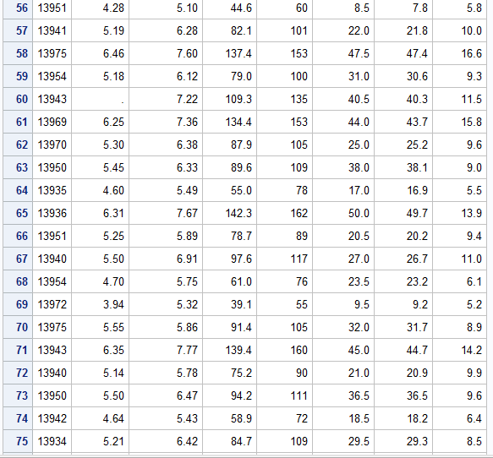

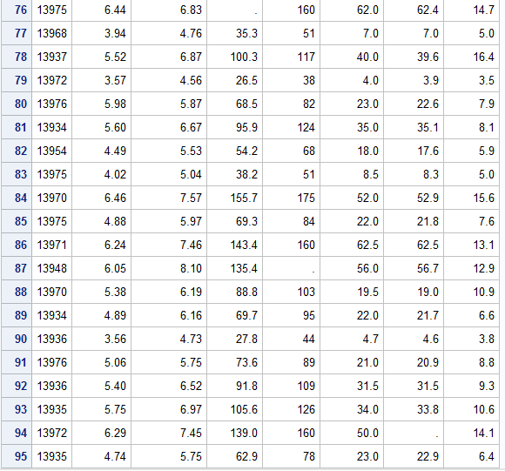

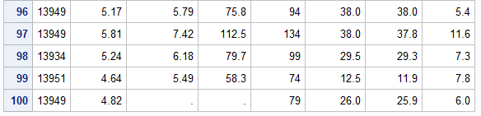

5

Code:

**data** college.hanks;

infile "C:\Users\Samil\Desktop\Sem 1\Stats for programming\SAS 9.4\hanks.txt" firstobs=**2** expandtabs missover;

input Title $25. Year Length MPAA $ Action Drama Humor Sex Violence Suspense Offbeat;

**run**;

**proc** **print** data=college.hanks;

Title 'Hanks';

**run**;

Title;

Log File:

97 data college.hanks;

98 infile "C:\Users\Samil\Desktop\Sem 1\Stats for programming\SAS 9.4\hanks.txt" firstobs=2

98 ! expandtabs missover;

99 input Title $25. Year Length MPAA $ Action Drama Humor Sex Violence Suspense Offbeat;

100 run;

NOTE: The infile "C:\Users\Samil\Desktop\Sem 1\Stats for programming\SAS 9.4\hanks.txt" is:

Filename=C:\Users\Samil\Desktop\Sem 1\Stats for programming\SAS 9.4\hanks.txt,

RECFM=V,LRECL=32767,File Size (bytes)=2283,

Last Modified=14 September 2017 11:00:35,

Create Time=14 September 2017 11:00:34

NOTE: 22 records were read from the infile "C:\Users\Samil\Desktop\Sem 1\Stats for programming\SAS

9.4\hanks.txt".

The minimum record length was 98.

The maximum record length was 98.

NOTE: The data set COLLEGE.HANKS has 22 observations and 11 variables.

NOTE: DATA statement used (Total process time):

real time 0.03 seconds

cpu time 0.01 seconds

101

102 proc print data=college.hanks;

103 Title 'Hanks';

104 run;

NOTE: There were 22 observations read from the data set COLLEGE.HANKS.

NOTE: PROCEDURE PRINT used (Total process time):

real time 0.19 seconds

cpu time 0.03 seconds

105 Title;

Output:

